PHP Exercise 2

## PHP Object

Classes and objects are the two main aspects of object-oriented programming.

A class is a template for objects, and an object is an instance of a class.

When the individual objects are created, they inherit all the properties and behaviors from the class, but each object will have different values for the properties.

Let's assume we have a class named Car. A Car can have properties like model, color, etc. We can define variables like $model, $color, and so on, to hold the values of these properties.

When the individual objects (Volvo, BMW, Toyota, etc.) are created, they inherit all the properties and behaviors from the class, but each object will have different values for the properties.

If you create a __construct() function, PHP will automatically call this function when you create an object from a class.

class Car {

    public $color;

    public $model;

    public $engine;

    public function __construct($color, $model,$engine) {

      $this->color = $color;

      $this->model = $model;

      $this->engine=$engine;

    }

    public function message() {

      return "My car is a " . $this->color . " " . $this->model . "!".$this->engine."!";

    }

  }

  $myCar = new Car("black", "Volvo","CCwe");

  echo $myCar -> message();

  echo "<br>";

  $myCar = new Car("red", "Toyota","BBWW");

  echo $myCar -> message();

?>

 <?php

//------------------------------------------------------

class Car{

    public $engine;

    public $model;

    public $batch;

    public $RegNo;

    public $hp;

    public $vol;

    public function __construct($engine,$model,$batch,$RegNo,$hp,$vol)

    {

$this->engine=$engine;

$this->model=$model;

$this->batch=$batch;

$this->RegNo=$RegNo;

$this->hp=$hp;

$this->vol=$vol;

    }

    public function message()

    {

        return "My car is : ".$this->engine."<br>"."Model is :".$this->model.

        "<br>"."Batch of car  is :"

        .$this->batch."<br>"."Registration of car is  :".$this->RegNo."";

    }

    public function engine(){

        return "My car engine HP poer is :".$this->hp."<br>"

        ."volume of car is ".$this->vol."";

    }

}

$mycar=new Car("CC45","BMW","45G",7864533,456,"789V");

echo $mycar->message();

echo "<br>";

echo $mycar->engine();

echo '<br>';

$mycar2=new Car("CC55","QMW","75M",5646477433,567,"897V");

echo $mycar2->message();

echo "<br>";

echo $mycar2->engine();

?>

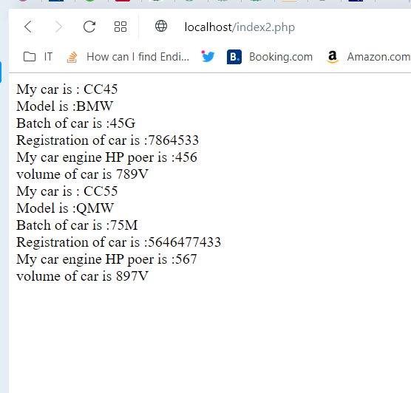

 <?php

//------------------------------------------------------

class Car{

    public $engine;

    public $model;

    public $batch;

    public $RegNo;

    public $hp;

    public $vol;

    public function __construct($engine,$model,$batch,$RegNo,$hp,$vol)

    {

$this->engine=$engine;

$this->model=$model;

$this->batch=$batch;

$this->RegNo=$RegNo;

$this->hp=$hp;

$this->vol=$vol;

    }

    public function message()

    {

        return "My car is : ".$this->engine."<br>"."Model is :".$this->model.

        "<br>"."Batch of car  is :"

        .$this->batch."<br>"."Registration of car is  :".$this->RegNo."";

    }

    public function engine(){

        return "My car engine HP poer is :".$this->hp."<br>"

        ."volume of car is ".$this->vol."";

    }

    public function suma($x,$y){

        $this->z=$x+$y;

        return "the sum of two number is :".$this->z;

    }

    public function customer($fname,$mname,$lname,$age,$city){

        echo "Below is the customers informations ";

        echo "<br>";

        $this->fname=$fname;

        $this->mname=$mname;

        $this->lname=$lname;

        $this->age=$age;

        $this->city=$city;

        return "First name:".$this->fname."<br>"."Middle name:".$this->mname."<br>"."last name:".$this->lname."<br>"

        ."Age is :".$this->age."<br>"."city is :".$this->city."";

    }

}

$mycar=new Car("CC45","BMW","45G",7864533,456,"789V");

echo $mycar->message();

echo "<br>";

echo $mycar->engine();

echo '<br>';

echo $mycar->suma(567,786);

echo '<br>';

echo "<br>";

echo $mycar->customer("ajman","ullah ","khan",24,"islamabad");

echo '<br>';

echo "<br>";

$mycar2=new Car("CC55","QMW","75M",5646477433,567,"897V");

echo $mycar2->message();

echo "<br>";

echo $mycar2->engine();

echo "<br>";

echo $mycar2->suma(890,806);

echo '<br>';

echo "<br>";

echo $mycar2->customer("Kalim","ullah ","khan",25,"Bannu");

?>

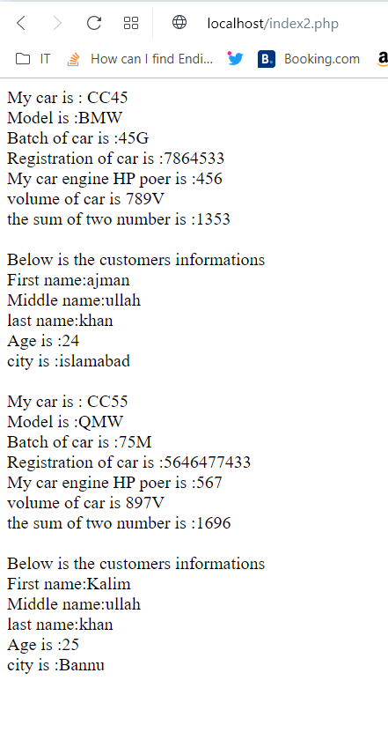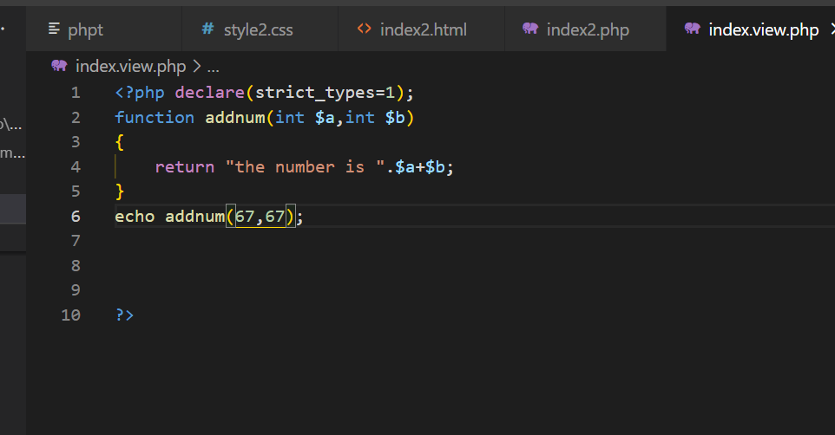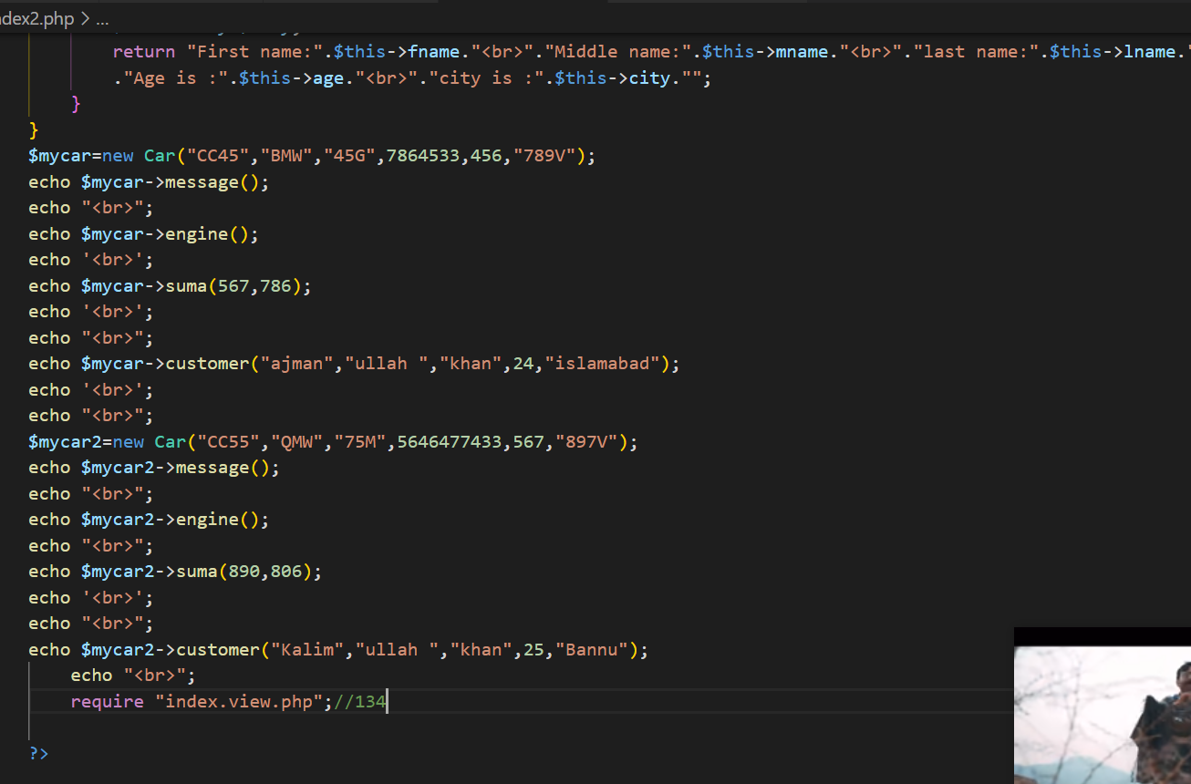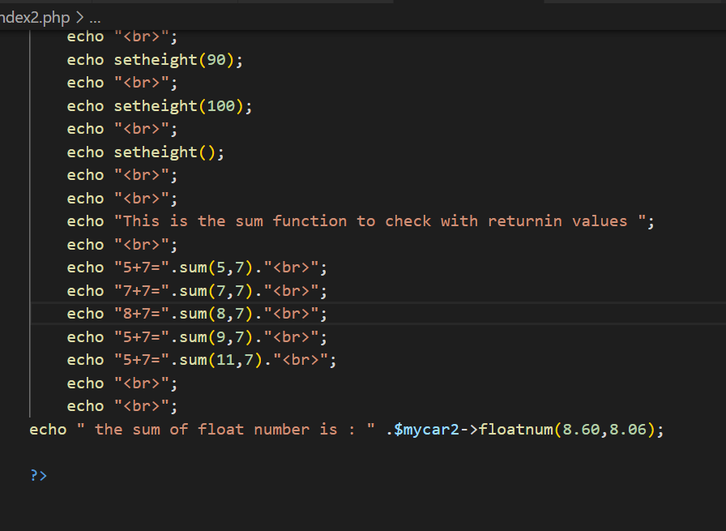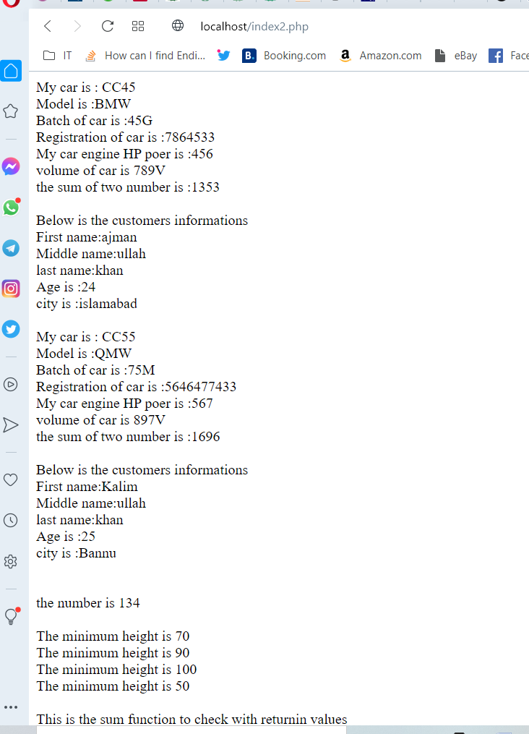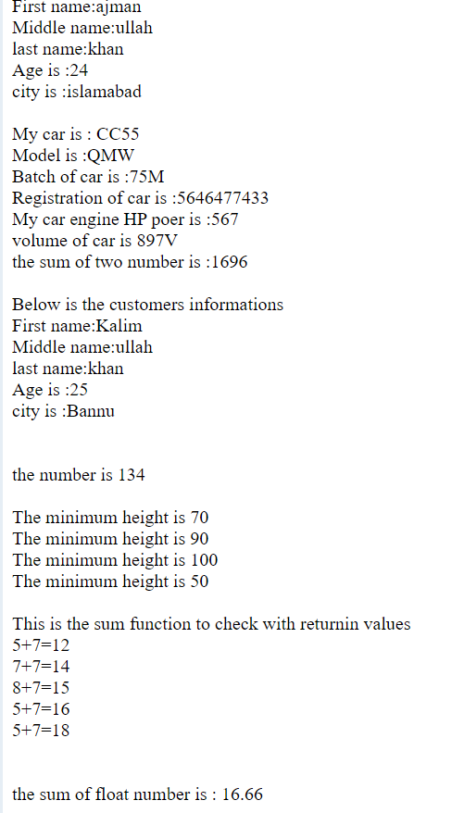

 <?php

//------------------------------------------------------

class Car{

    public $engine;

    public $model;

    public $batch;

    public $RegNo;

    public $hp;

    public $vol;

    public function __construct($engine,$model,$batch,$RegNo,$hp,$vol)

    {

$this->engine=$engine;

$this->model=$model;

$this->batch=$batch;

$this->RegNo=$RegNo;

$this->hp=$hp;

$this->vol=$vol;

    }

    public function message()

    {

        return "My car is : ".$this->engine."<br>"."Model is :".$this->model.

        "<br>"."Batch of car  is :"

        .$this->batch."<br>"."Registration of car is  :".$this->RegNo."";

    }

    public function engine(){

        return "My car engine HP poer is :".$this->hp."<br>"

        ."volume of car is ".$this->vol."";

    }

    public function suma($x,$y){

        $this->z=$x+$y;

        return "the sum of two number is :".$this->z;

    }

    public function floatnum(float $a,float $b):float{

        return $a+$b;

    }

    public function customer($fname,$mname,$lname,$age,$city){

        echo "Below is the customers informations ";

        echo "<br>";

        $this->fname=$fname;

        $this->mname=$mname;

        $this->lname=$lname;

        $this->age=$age;

        $this->city=$city;

        return "First name:".$this->fname."<br>"."Middle name:".$this->mname.

        "<br>"."last name:".$this->lname."<br>"

        ."Age is :".$this->age."<br>"."city is :".$this->city."";

    }

}

$mycar=new Car("CC45","BMW","45G",7864533,456,"789V");

echo $mycar->message();

echo "<br>";

echo $mycar->engine();

echo '<br>';

echo $mycar->suma(567,786);

echo '<br>';

echo "<br>";

echo $mycar->customer("ajman","ullah ","khan",24,"islamabad");

echo '<br>';

echo "<br>";

$mycar2=new Car("CC55","QMW","75M",5646477433,567,"897V");

echo $mycar2->message();

echo "<br>";

echo $mycar2->engine();

echo "<br>";

echo $mycar2->suma(890,806);

echo '<br>';

echo "<br>";

echo $mycar2->customer("Kalim","ullah ","khan",25,"Bannu");

    echo "<br>";

    echo "<br>";

    echo "<br>";

    require "index.view.php";

    echo addnum(67,67);//134

    echo "<br>";

    echo "<br>";

    echo setheight(70);

    echo "<br>";

    echo setheight(90);

    echo "<br>";

    echo setheight(100);

    echo "<br>";

    echo setheight();

    echo "<br>";

    echo "<br>";

    echo "This is the sum function to check with returnin values ";

    echo "<br>";

    echo "5+7=".sum(5,7)."<br>";

    echo "7+7=".sum(7,7)."<br>";

    echo "8+7=".sum(8,7)."<br>";

    echo "5+7=".sum(9,7)."<br>";

    echo "5+7=".sum(11,7)."<br>";

    echo "<br>";

    echo "<br>";

echo " the sum of float number is : " .$mycar2->floatnum(8.60,8.06);

?>

Index.view.php

<?php declare(strict_types=1);

function addnum(int $a,int $b)

{

    return "the number is ".$a+$b;

}

function setheight(int $minheight=50){

    echo "The minimum height is $minheight";

}

function sum(int $x,int $y)

{

    $z=$x+$y;

    return $z;

}

?

Output:

My car is : CC45  
Model is :BMW  
Batch of car is :45G  
Registration of car is :7864533  
My car engine HP poer is :456  
volume of car is 789V  
the sum of two number is :1353  
  
Below is the customers informations  
First name:ajman  
Middle name:ullah  
last name:khan  
Age is :24  
city is :islamabad  
  
My car is : CC55  
Model is :QMW  
Batch of car is :75M  
Registration of car is :5646477433  
My car engine HP poer is :567  
volume of car is 897V  
the sum of two number is :1696  
  
Below is the customers informations  
First name:Kalim  
Middle name:ullah  
last name:khan  
Age is :25  
city is :Bannu  
  
  
the number is 134  
  
The minimum height is 70  
The minimum height is 90  
The minimum height is 100  
The minimum height is 50  
  
This is the sum function to check with returnin values  
5+7=12  
7+7=14  
8+7=15  
5+7=16  
5+7=18  
  
  
the sum of float number is : 16.66

 <?php

//------------------------------------------------------

class Car{

    public $engine;

    public $model;

    public $batch;

    public $RegNo;

    public $hp;

    public $vol;

    public function __construct($engine,$model,$batch,$RegNo,$hp,$vol)

    {

$this->engine=$engine;

$this->model=$model;

$this->batch=$batch;

$this->RegNo=$RegNo;

$this->hp=$hp;

$this->vol=$vol;

    }

    public function message()

    {

        return "My car is : ".$this->engine."<br>"."Model is :".$this->model.

        "<br>"."Batch of car  is :"

        .$this->batch."<br>"."Registration of car is  :".$this->RegNo."";

    }

    public function engine(){

        return "My car engine HP poer is :".$this->hp."<br>"

        ."volume of car is ".$this->vol."";

    }

    public function suma($x,$y){

        $this->z=$x+$y;

        return "the sum of two number is :".$this->z;

    }

    public function floatnum(float $a,float $b):float{

        return $a+$b;

    }

    public function customer($fname,$mname,$lname,$age,$city){

        echo "Below is the customers informations ";

        echo "<br>";

        $this->fname=$fname;

        $this->mname=$mname;

        $this->lname=$lname;

        $this->age=$age;

        $this->city=$city;

        return "First name:".$this->fname."<br>"."Middle name:".$this->mname.

        "<br>"."last name:".$this->lname."<br>"

        ."Age is :".$this->age."<br>"."city is :".$this->city."";

    }

}

$mycar=new Car("CC45","BMW","45G",7864533,456,"789V");

echo $mycar->message();

echo "<br>";

echo $mycar->engine();

echo '<br>';

echo $mycar->suma(567,786);

echo '<br>';

echo "<br>";

echo $mycar->customer("ajman","ullah ","khan",24,"islamabad");

echo '<br>';

echo "<br>";

$mycar2=new Car("CC55","QMW","75M",5646477433,567,"897V");

echo $mycar2->message();

echo "<br>";

echo $mycar2->engine();

echo "<br>";

echo $mycar2->suma(890,806);

echo '<br>';

echo "<br>";

echo $mycar2->customer("Kalim","ullah ","khan",25,"Bannu");

    echo "<br>";

    echo "<br>";

    echo "<br>";

    require "index.view.php";

    echo addnum(67,67);//134

    echo "<br>";

    echo "<br>";

    echo setheight(70);

    echo "<br>";

    echo setheight(90);

    echo "<br>";

    echo setheight(100);

    echo "<br>";

    echo setheight();

    echo "<br>";

    echo "<br>";

    echo "This is the sum function to check with returnin values ";

    echo "<br>";

    echo "5+7=".sum(5,7)."<br>";

    echo "7+7=".sum(7,7)."<br>";

    echo "8+7=".sum(8,7)."<br>";

    echo "5+7=".sum(9,7)."<br>";

    echo "5+7=".sum(11,7)."<br>";

    echo "<br>";

    echo "<br>";

echo " the sum of float number is : " .$mycar2->floatnum(8.60,8.06);

echo "<br>";

$num = 2;

add_five($num);

echo "the number with passing a referenece    :".$num." " ;

echo "<br>";

echo "<br>";

$nu=5;

add_num($nu);

echo "the number with mult    : ". $nu." ";

?>

Index.view.php

<?php declare(strict_types=1);

function addnum(int $a,int $b)

{

    return "the number is ".$a+$b;

}

function setheight(int $minheight=50){

    echo "The minimum height is $minheight";

}

function sum(int $x,int $y):int

{

    $z=$x+$y;

    return $z ;

}

function add_five(&$value) {

    $value += 5;

  }

  function add_num(&$value){

     $value*=7;

  }

?>

Output:

My car is : CC45  
Model is :BMW  
Batch of car is :45G  
Registration of car is :7864533  
My car engine HP poer is :456  
volume of car is 789V  
the sum of two number is :1353  
  
Below is the customers informations  
First name:ajman  
Middle name:ullah  
last name:khan  
Age is :24  
city is :islamabad  
  
My car is : CC55  
Model is :QMW  
Batch of car is :75M  
Registration of car is :5646477433  
My car engine HP poer is :567  
volume of car is 897V  
the sum of two number is :1696  
  
Below is the customers informations  
First name:Kalim  
Middle name:ullah  
last name:khan  
Age is :25  
city is :Bannu  
  
  
the number is 134  
  
The minimum height is 70  
The minimum height is 90  
The minimum height is 100  
The minimum height is 50  
  
This is the sum function to check with returnin values  
5+7=12  
7+7=14  
8+7=15  
5+7=16  
5+7=18  
  
  
the sum of float number is : 16.66  
the number with passing a referenece :7  
  
the number with mult : 35

